Task: Deploy a Static Website Using Amazon S3, CloudFront, Route 53, and GoDaddy Domain
Objective
Host a static website on Amazon S3, deliver it securely through Amazon CloudFront using an SSL certificate, map your GoDaddy domain using Route 53, and verify the website is accessible via your custom domain.

Step 1: Purchase a Domain from GoDaddy
Purpose
Purchase a custom domain name that visitors will use to access your website.
Steps
- Open https://godaddy.com
- Sign in or create a GoDaddy account.
- Search for your preferred domain name.
- Select an available domain.
- Click Add to Cart.
- Proceed to Checkout.
- Complete the payment.
- After purchase, verify the domain appears under My Products.
Example
Sarfaraztechie.site

Step 2: Create an S3 Bucket
Purpose
Create a storage bucket that will host the static website files.
Steps
- Login to AWS Console.
- Search for S3.
- Click Create bucket.
- Enter Bucket Name.
Example
exampledomain.com
- Select Region.
Example
US East (N. Virginia)
- Uncheck
Block all public access
- Accept the warning.
- Click Create Bucket.
Evidence
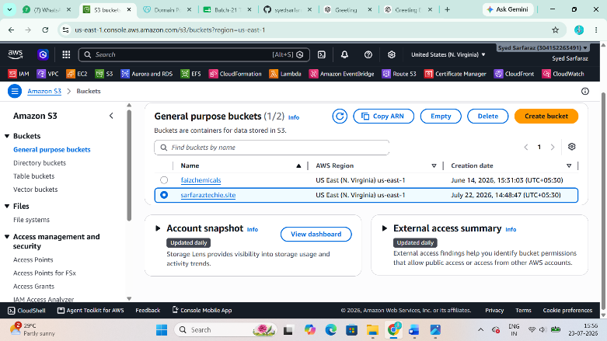
Step 3: Upload Website Files
Purpose
Upload the HTML, CSS, JavaScript, and image files to the bucket.
Steps
- Open the bucket.
- Click Upload.
- Select
index.html
and other website files.
- Click Upload.
Evidence
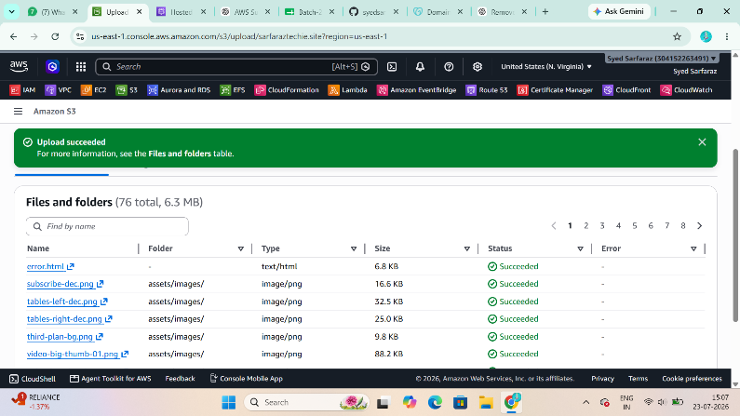
Step 4: Enable Static Website Hosting
Purpose
Allow Amazon S3 to host the uploaded files as a website.
Steps
- Open the bucket.
- Select the Properties tab.
- Scroll to
Static website hosting
- Click Edit.
- Select
Enable
- Hosting Type
Host a static website
- Index document
index.html
- Error document
error.html
(Optional)
- Save changes.
- Copy the Website Endpoint.
Example
http://exampledomain.com.s3-website-us-east-1.amazonaws.com
Evidence
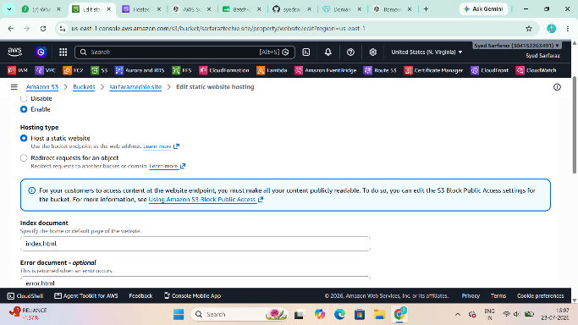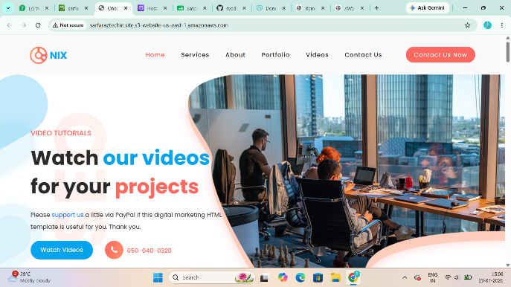
Step 5: Add Bucket Policy
Purpose
Allow CloudFront (or the website if testing publicly) to access the website content.
Steps
Go to
Permissions
Click
Bucket Policy
Paste
{
"Version":"2012-10-17",
"Statement":[
{
"Sid":"PublicRead",
"Effect":"Allow",
"Principal":"*",
"Action":"s3:GetObject",
"Resource":"arn:aws:s3:::exampledomain.com/*"
}
]
}
Replace
exampledomain.com
with your bucket name.
Save.
Evidence
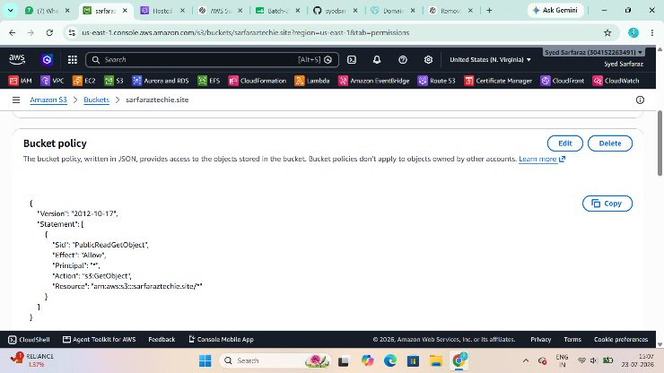

Step 6: Request SSL Certificate (AWS Certificate Manager)
Purpose
Create a free SSL certificate so your website can use HTTPS.
Important
CloudFront requires the certificate to be created in
US East (N. Virginia)
Steps
- Search
Certificate Manager
- Click
Request Certificate
- Select
Request a public certificate
- Domain Name
exampledomain.com
Click
Add another name
Add
www.exampledomain.com
- Validation Method
DNS Validation
- Request Certificate.
Evidence
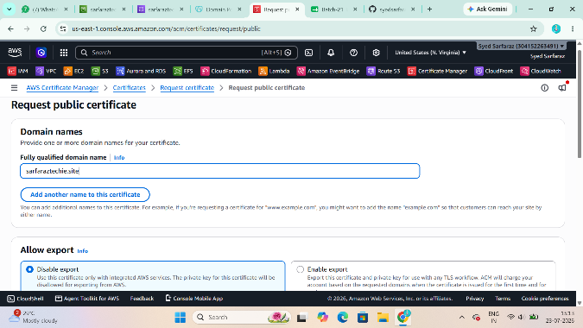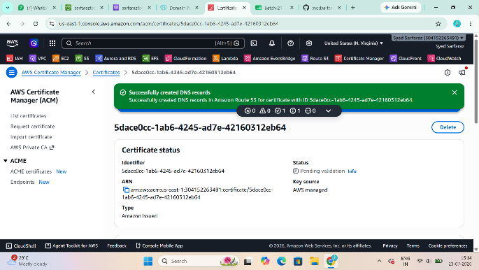
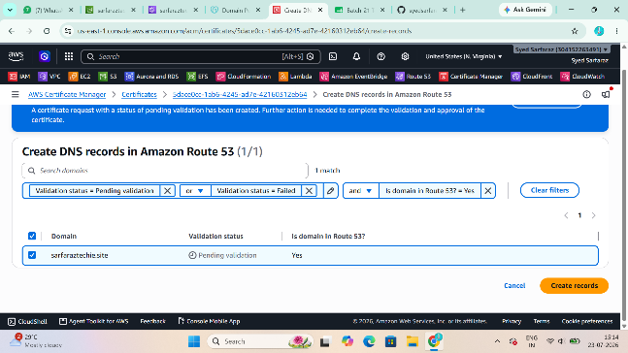
Step 7: Validate SSL Certificate
Purpose
Prove ownership of the domain so AWS can issue the certificate.
Steps
- Open the certificate.
- Copy the CNAME record.
- Login to GoDaddy.
- Open DNS Management.
- Add
Type: CNAME
- Paste the Name and Value provided by ACM.
- Save.
- Wait until status becomes
Issued
Evidence
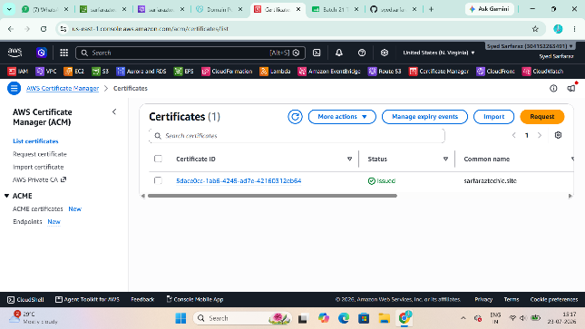
Step 8: Create CloudFront Distribution
Purpose
Deliver the website globally with low latency, HTTPS, caching, and improved performance.
Steps
- Search
CloudFront
- Click
Create Distribution
Origin
Choose
S3 Website Endpoint
or your S3 origin as appropriate.
Default Root Object
index.html
Viewer Protocol
Redirect HTTP to HTTPS
Alternate Domain Names
exampledomain.com
www.exampledomain.com
Custom SSL Certificate
Select the ACM certificate created earlier.
Click
Create Distribution
Wait until status becomes
Deployed
Copy the Distribution Domain.
Example
d3x9abcxyz.cloudfront.net
Evidence
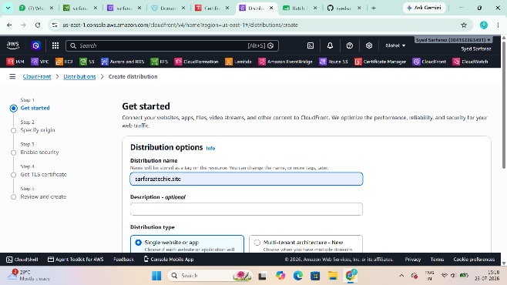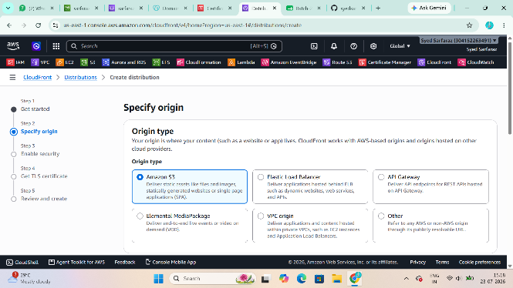
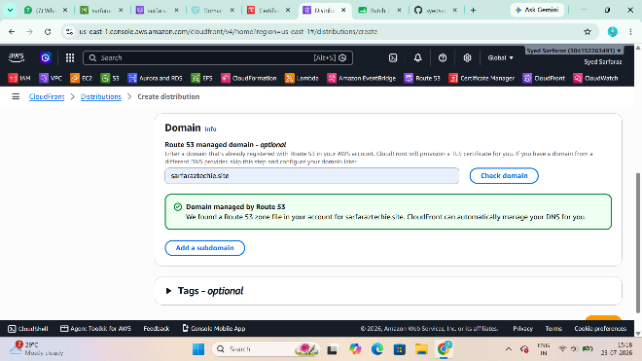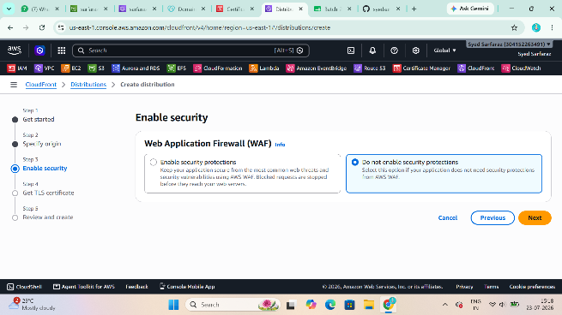
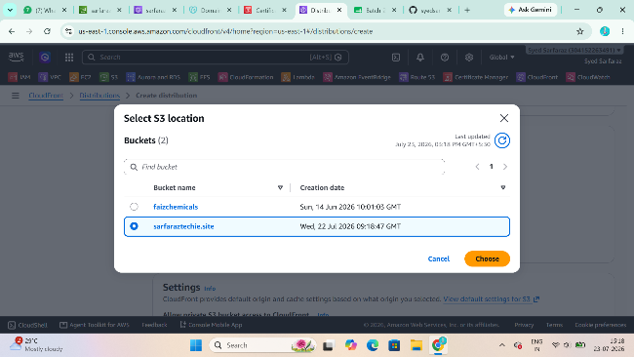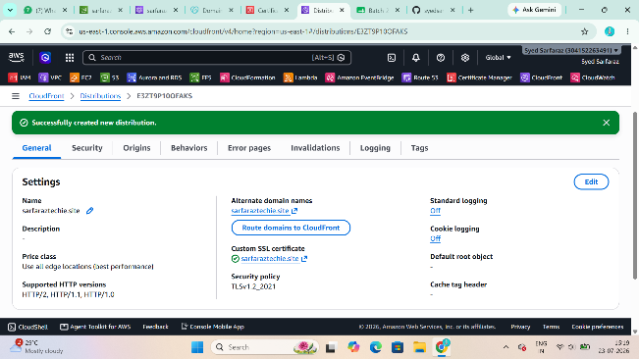

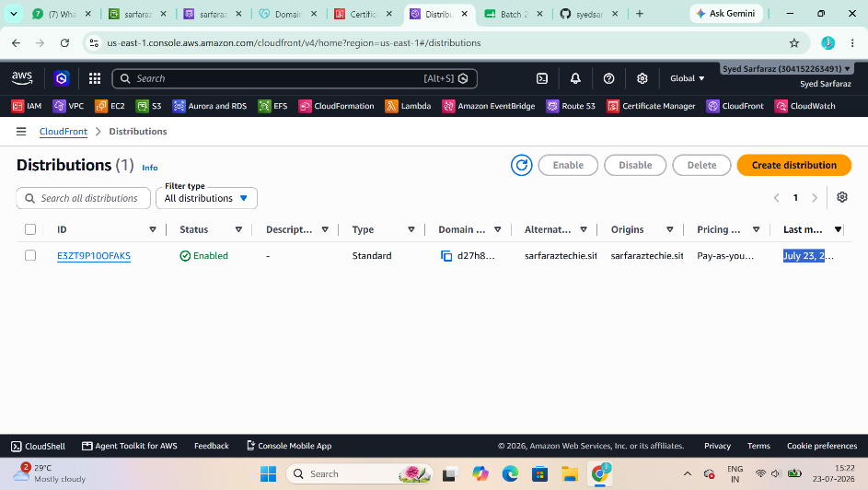

Step 9: Create Route 53 Hosted Zone
Purpose
Store DNS records that direct your domain to CloudFront.
Steps
- Search
Route 53
- Click
Hosted Zones
- Click
Create Hosted Zone
Domain
exampledomain.com
Type
Public Hosted Zone
Click
Create Hosted Zone
Evidence
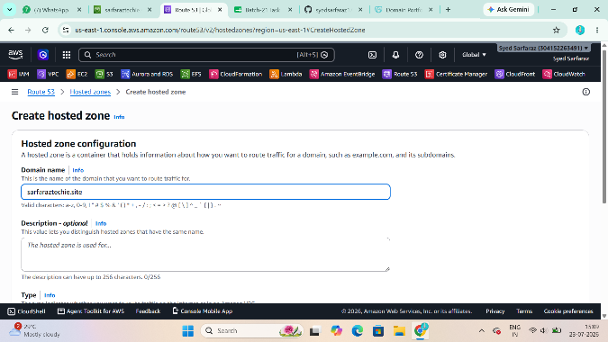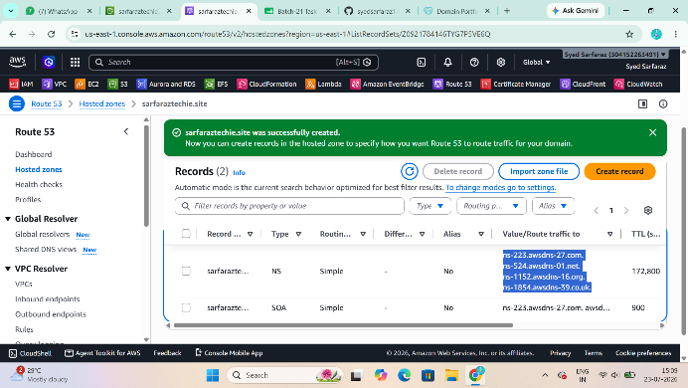
Step 10: Update GoDaddy Nameservers
Purpose
Delegate DNS management from GoDaddy to Route 53.
Steps
In Route 53 copy all four
NS Records
Open GoDaddy
Domain → DNS → Nameservers
Choose
Use my own nameservers
Paste all four AWS nameservers.
Save.
Wait
15 minutes to 48 hours
for propagation.
Evidence
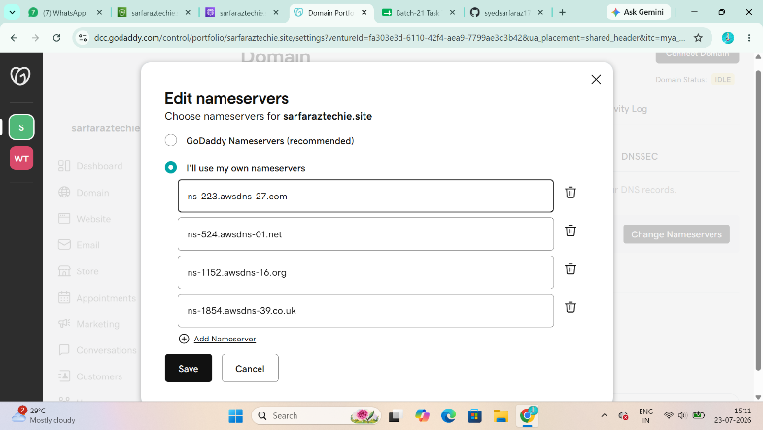
Step 11: Create Alias Record
Purpose
Map the domain name to the CloudFront distribution.
Steps
Inside Hosted Zone
Click
Create Record
Record Type
A
Enable
Alias
Select
CloudFront Distribution
Choose your distribution.
Save.
Repeat for
www
(Optional)
Evidence
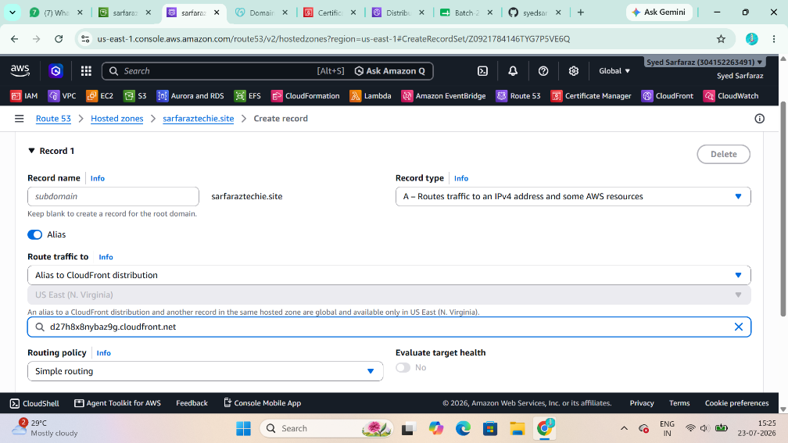
Step 12: Test the Website
Purpose
Verify the website loads successfully using your custom domain.
Open browser
https://exampledomain.com
Verify
- Website loads successfully.
- HTTPS lock icon is visible.
- No certificate warnings.
- Images and CSS load correctly.
Evidence
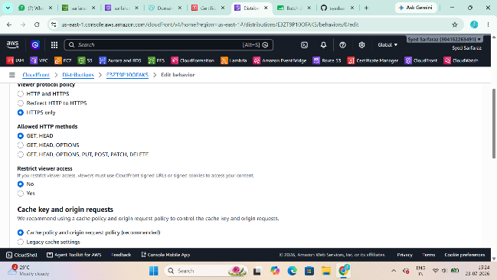
Step 13: Update index.html
Purpose
Verify that changes to the website are reflected when accessed through the custom domain.
Steps
- Edit the local index.html file.
- Add a visible change, such as:
<h1>Welcome to My Updated Website</h1>
<p>Updated on 23 July 2026</p>
- Save the file.
- Upload the updated index.html to the S3 bucket, replacing the existing file.
- In CloudFront, create an invalidation:
  - Go to CloudFront → Your Distribution → Invalidations.
  - Click Create Invalidation.
  - Enter:
  - Click Create Invalidation.
- Refresh your website using:
https://exampledomain.com
- Confirm the updated content is displayed.
Evidence
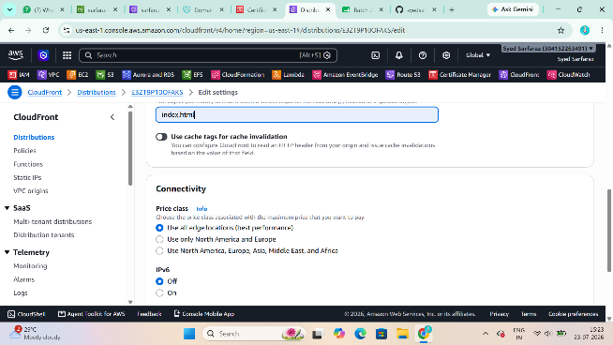
Step 14: Share the Domain in Slack
My static website deployment is complete.

Website URL:
https://sarfaraztechie.life

Evidence
